Declaration of applicable specific categories

If you are applying to Nagoya University as a faculty member or student, we ask you to declare whether you are subject to “deemed exports” controls under the Foreign Exchange and Foreign Trade Act (“FEFTA”).
Please refer to the attached flowchart for your position, check the appropriate boxes, and submit it together with your application form and documents.

Department Institute for Advanced Research* *Unchangeable
Name

□ Category 1 applies □ Category 2 applies □ Category 3 applies □ No categories apply

If you fall into one of the Categories 1 to 3, please provide a reason below and submit the relevant evidence.
Reason for applicability
(e.g., employed by __ institution, receiving funding/scholarship from __, or planning to do so)
（ ）
Evidence
(e.g., proof of employment by a foreign organization (letter of employment/contract), letter of funding from a foreign organization (individual), notice of scholarship award or application form)
（ ）

*Please contact us if you are unsure whether any of the above categories apply.
Academic Research & Industry‐Academia‐Government collaboration Export Control Division E-mail：anzen@aip.nagoya-u.ac.jp TEL：052-747-6702

Attachment
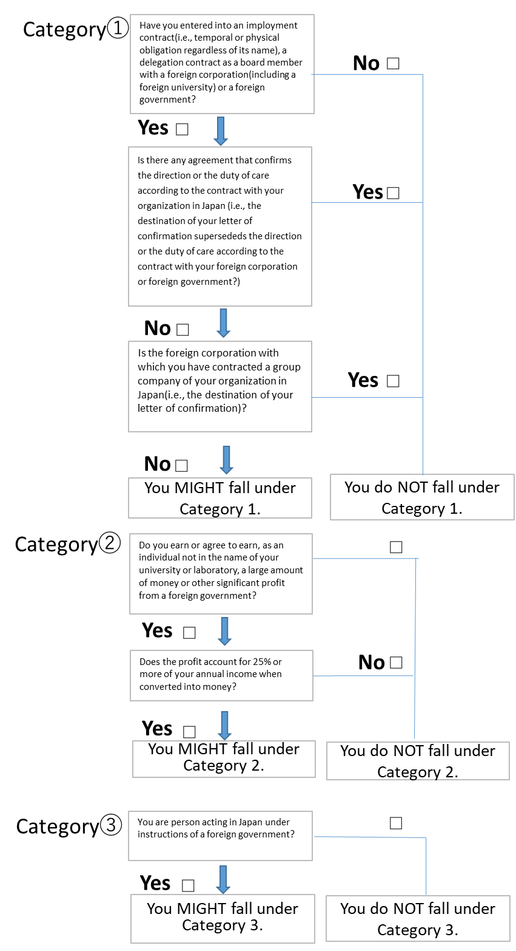
Flowchart for Determining Applicable Categories

